 **Team Name: Dev Disruptors**

**Wizard of System Programming**



**Team Members:**

**Chhawinderpreet**

**Mudit**

**Tushar**

**Flash Page(Logo)**



**Home Page**

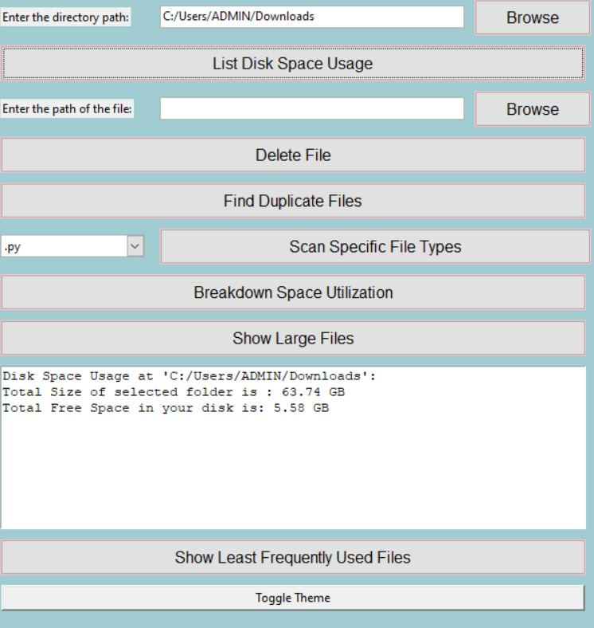

The "Browse" feature allows you to search for specific files on which you wish to perform operations.

The "List Disk Space Usage" feature provides you with the total size of the selected folder and the amount of free space available on your disk.

**Break Down Of Space Utilization**

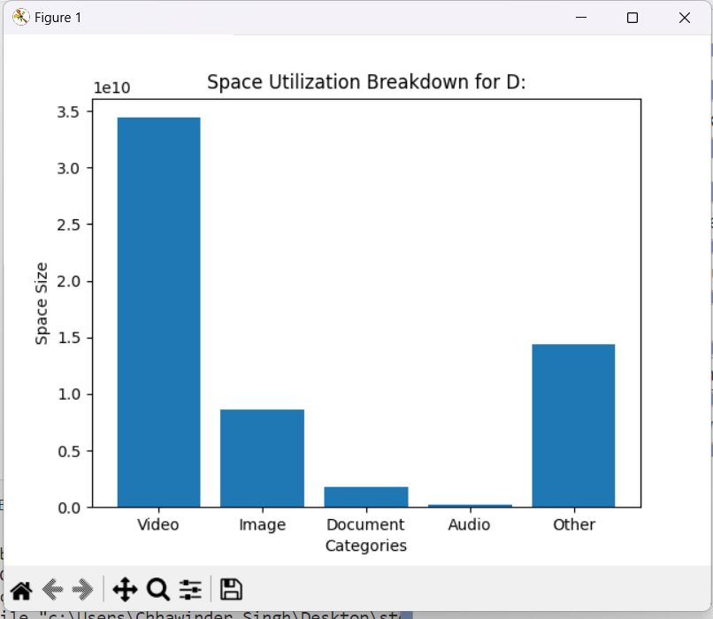

The feature provides a breakdown of storage occupied by files based on their file formats, such as video, image, audio, and document files. It gives you insights into how much space each file format is consuming on your storage.

**Find Duplicate Files**

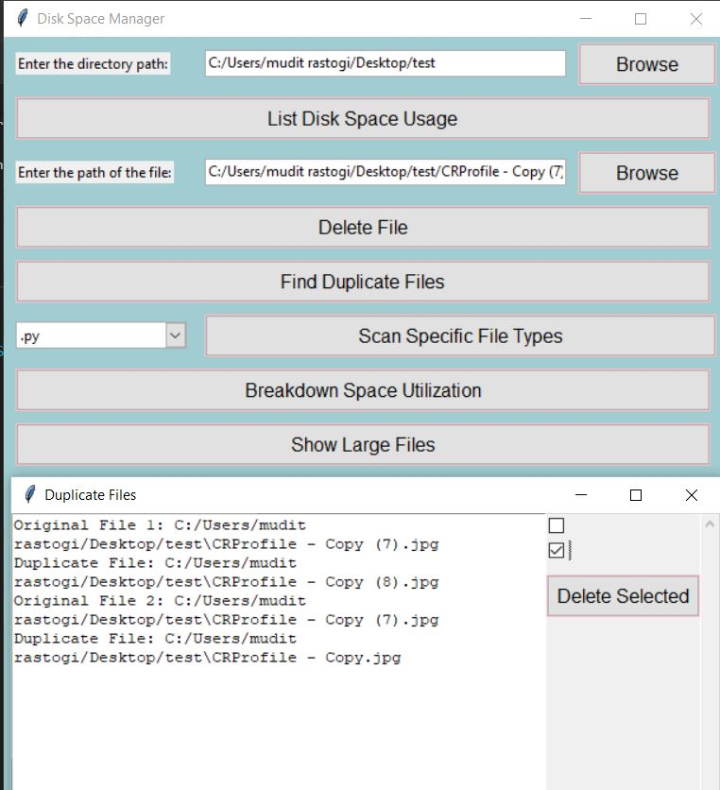

We chose to utilize the SHA-256 algorithm for hashing rather than MD-5 due to its substantial enhancements in security and collision resistance. The longer hash length generated by SHA-256 provides increased security against potential attacks. Its strong cryptographic properties make it a more dependable option for safeguarding data integrity and securing sensitive information.

**Delete Large Files**

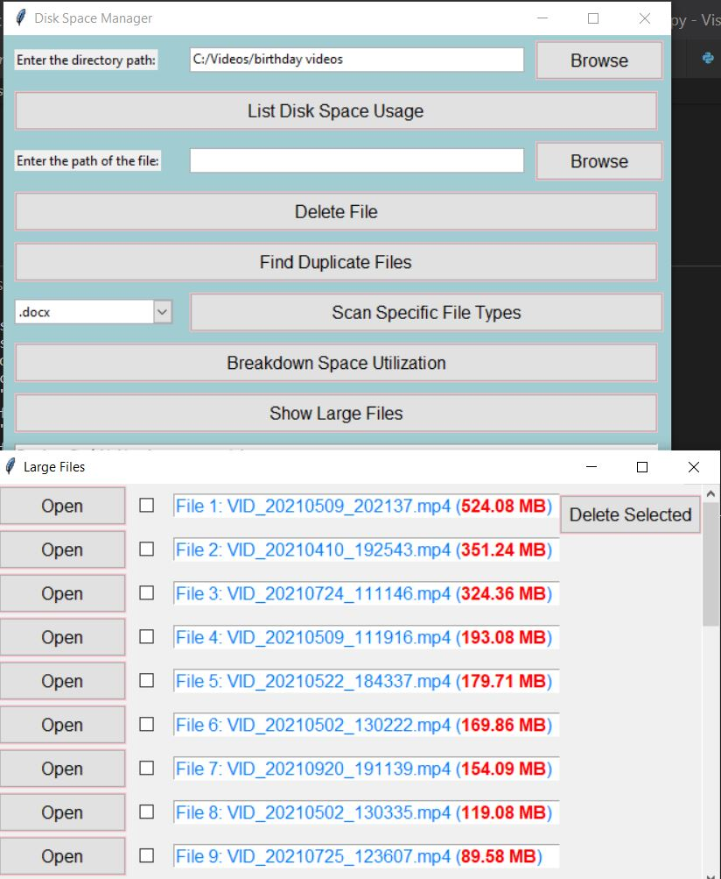

Users have the option to open files and review their contents before deciding whether to delete them. Additionally, we have set a threshold of 3 MB for file sizes, which users can adjust according to their specific needs and preferences.

**Scan Specific File Types**

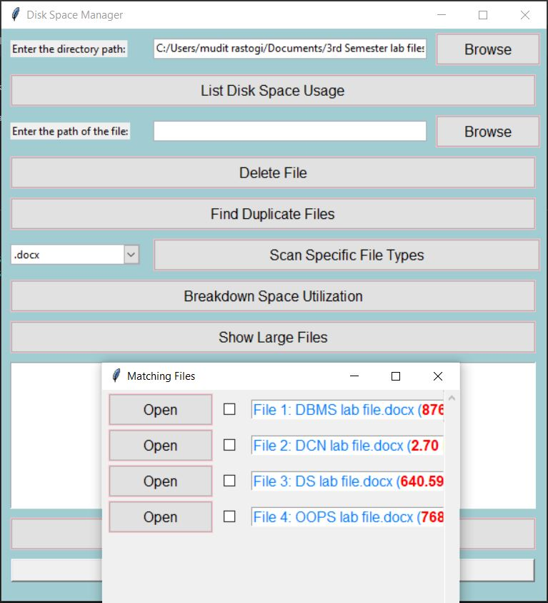

Search in the directory for the specific type of file selected by the user.

**Delete The Selected Files** 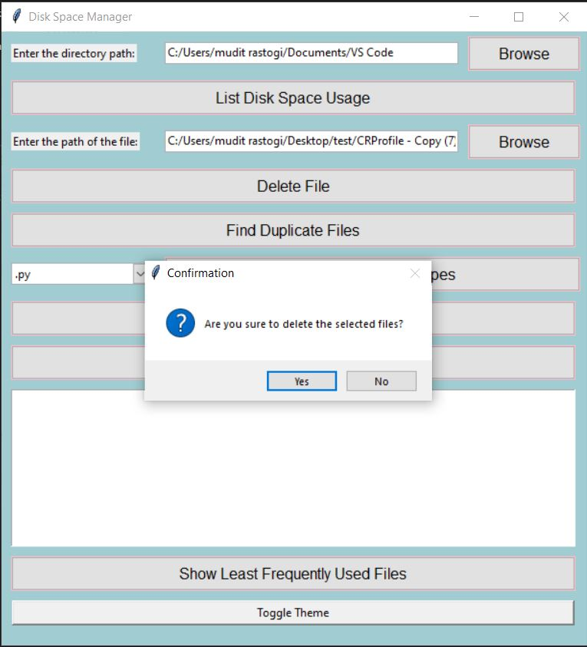

A confirmation prompt box is presented to the user, allowing them to confirm their decision to delete the selected files. This ensures that the user can make a deliberate choice before proceeding with the deletion.

**Least Frequently Used**

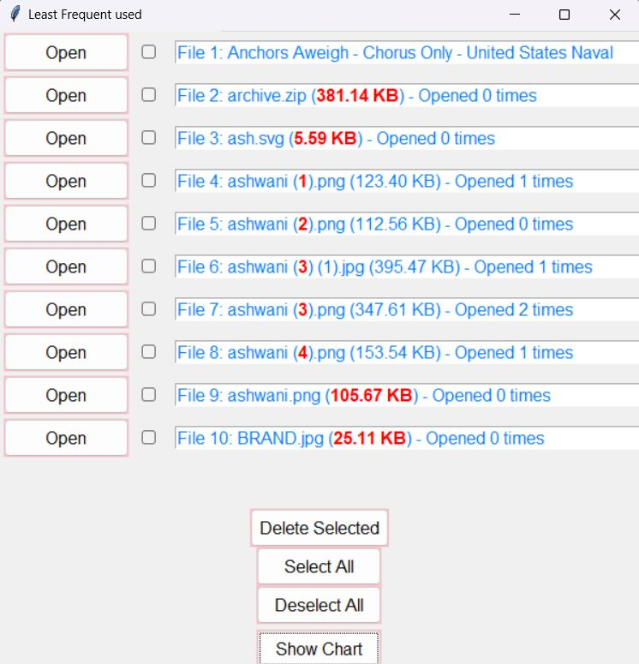

The application allows users to select multiple least frequently used files simultaneously. Additionally, it displays the frequency of each file's usage. By default, the application shows the 10 least frequently used files, but users can easily adjust this threshold to display more or fewer files according to their preferences.